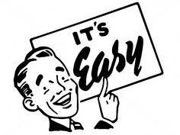
Your Network and You!
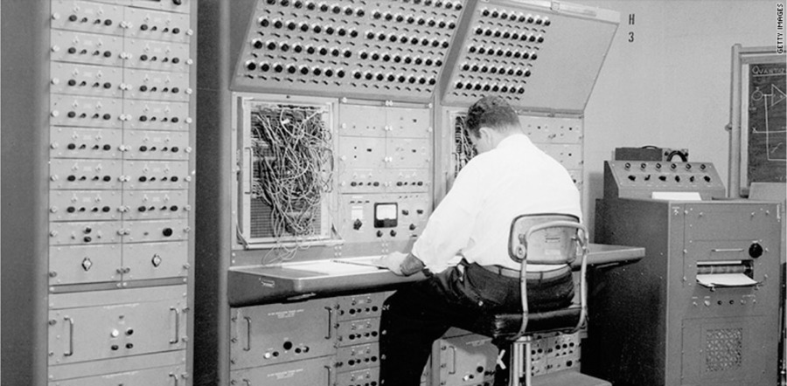
A NOECA Technical Educational Series
A comprehensive series about your network and how to troubleshoot it!
If you ever wanted to sharpen your network skills, understand how data traverses the network, or just thought the blinking lights were pretty, then this educational series is for YOU! Look below and sign up for a free class today.
- Intro to the Network – Find out how bits travel and learn some Cisco Stuff to show off to your friends. This two hour class will go over a packet’s path through the network to access NOECA, OARnet, and Internet resources. Plus, we will login to a Cisco switch and show some nifty commands. This class will be on Nov 1st from 9a-11a. If interest please sign up at events.noeca.net.
Other classes will be scheduled real soon and they are:
-Basic Network Troubleshooting and understanding of the OSI model.
-How NOECA filters and manages traffic to secure the network.
- The Magic of VLANS and the Mystery of Subnets Revealed
- Cables and Media – how to manage your own and not get tangled.
Classes will be available in person and webinar.

Contact Eric or George for more information!

